**Logical Model for Traffic Flow Management System:**

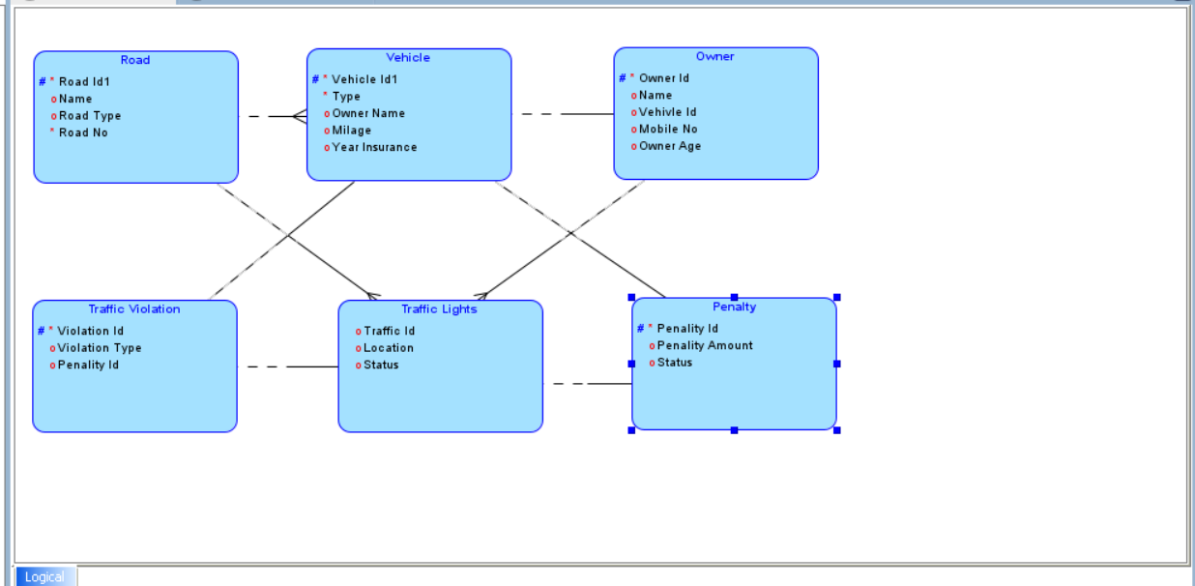

**Relational Model for Traffic Flow Management System:**

